CS-499 Artifact 3 Narrative
Jennifer Gwinn
4/19/26
The original artifact was a C++ program that allows a user to load a CSV file into a has table and then complete CRUD operations. The user interface is a command line menu that responds to numeric menu selections. This program is partially starter code provided by an instructor from CS300 at SNHU, with final enhancements being February 2025.
This artifact was selected to serve as the demonstration for all of the capstone requirements, including databases. Up to this point, the original artifact has been enhanced by replacing the C++ command line menu UI with a web-based user interface. The artifact was then enhanced further by replacing the original hash structure with an SQL-backed database to allow for more efficient filtering and querying, and by replacing the original static HTML with dynamic live data. For the final enhancement, proficiency in databases was demonstrated by adding a restriction at the data level to support role-based permissions. Specifically, a “funds” data table was created to store the types of funds that have “unrestricted” access, and this is used to ensure “general” users cannot view any information related to bids in the “Enterprise” fund.
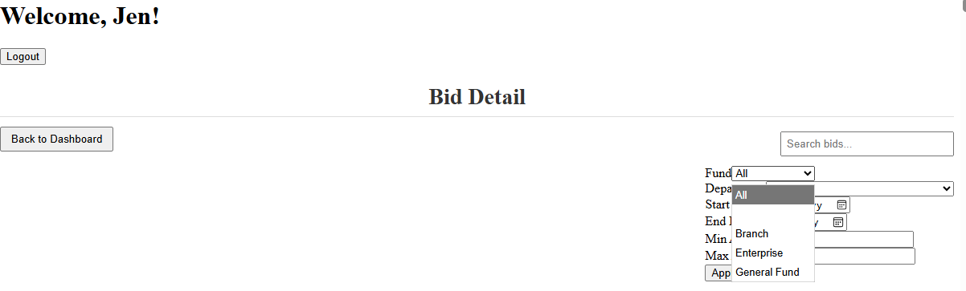
Filter options for "admin" user

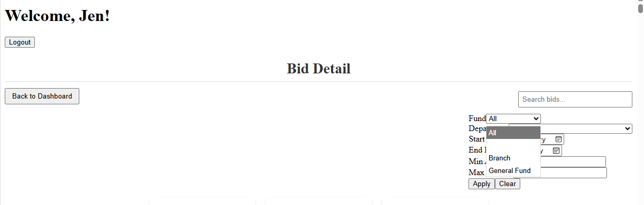
Filter options for "general" user
Adding this enhancement demonstrates a potential real-world scenario where data may need to be restricted based on the user and demonstrates a security mindset with role-based permissions.
Originally, the intention was to build the actual users in a MongoDB database, however through the course of development the plan pivoted to hard coding the user type in the TypeScript file to demonstrate the exclusion.
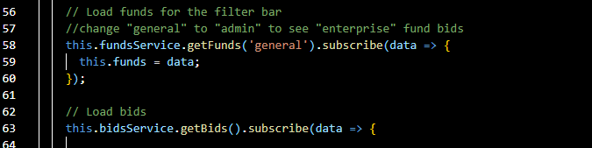
Excerpt from bid-details.component.ts
This leg of the capstone enhancement specifically highlighted the importance of having QA outside of just the programmer when “Enterprise” was excluded from the filter options but was still accessible by the keyword search. This is an example of something simple the programmer may miss being so focused on the filter bar, and another set of eyes uncovered something that could have been a major issue if a client truly needed the “Enterprise” funds bids to be hidden from general users.

